Module 10 b)
Accident-Prone
1)Remember the words from Module 10
2)What is an accident? Have you ever had an accident?
3)Do ex 1 on page 98 (SB)
4)Do the matching:
1 2 3 4 5 6
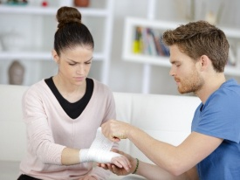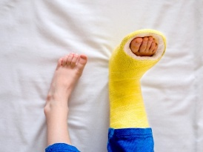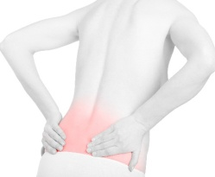

- hurt her back
- twist her ankle
- chip her tooth
- break her leg
- cut her finger
- sprain her wrist
5)Remember phrasal verbs and do the following exercise: (КАЖДАЯ БУКВА В КАЖДОМ ВАРИАНТЕ ДОЛЖНА БЫТЬ ЗАПОЛНЕНА)
1)Fill in: after, out of, into.
- Mike ran____ Nick on his way home.
- We ran ____ bread, so we went to buy some.
- The police are running ____ a robber.

2) Fill in: up, back, away.
- Give me____ my pen, please.
- John gave ____ smoking last year.
- Jack gave ____ his toy cars to little brother.
3)Fill in: on, off, with.
- Put the milk in the fridge or else it’ll go ___.
- This shirt goes really well ___ the jeans.
- Go ___. I didn’t mean to interrupt.
- The cat jumped onto the car and the alarm went ___.

4)Fill in: for, after, up, forward.
- What are you looking ___? My English textbook.
- Look ___ the words you don’t know in the dictionary.
- Students are really looking ___ their summer holidays.
- Who looks ___ your little sister when your parents are at work?
5)Fill in: back, out, across, round.
- The new film is coming ___ next month.
- Come ___ to our house any time.
- I came ___ this book in the shop yesterday.
- They came ___ to the country a month ago.

6)Fill in: into, on, off, in.
- Turn ___ the light when you leave the room.
- Can you turn ___ the news, please?
- In fairytales animals turn ___ people.
- It’s late. I think I’ll turn ___.

7)Fill in: out, up, up with
- She has made ___ her sister after the quarrel.
- I can’t make ___ this handwriting.
- This is not a real story. He made it ___.

8)Fill in: away, out, off, back.
- My patents always take us ___ on Saturdays.
- It was the wrong size, so I took it ___ to the shop.
- Can we eat a take ___ tonight?
- It’s hot here. Why don’t you take ___ your jumper?

9)Fill in: behind, out, apart.
- It’s hurtful when you fall ___ with friends.
- That chair has fallen ___. It needs fixing.
- If you revise regularly, you won’t fall ___ at school.

HOMEWORK:
1)Слова 10 модуля учить;
2)Учебник стр 98 упр 2

ВЫСЛАТЬ НА ПРОВЕРКУ УПРАЖНЕНИЕ ПО ФРАЗОВЫМ ГЛАГОЛАМ ДО 18 ЧАСОВ ВОСКРЕСЕНЬЯ, 17 МАЯ

